**USER MANUAL**

Integration of Industry 4.0 Standards

**Table of Contents**

What is it? 3

What is an Integration of Industry 4.0 Standards? 4

How to interact with the interface? 4

What is an input? 4

How to upload your input? 4

How to produce visualization? 5

How to produce an integrated file? 6

How to interact with the produced data? 6

How to communicate with developers? 8

# What is it?

This document is a user manual for the project “Integration of Industry 4.0 Standards”. The audience for the document includes both tutors of the Semantic Web Lab and ordinary users. This manual was created with an assumption that the final user is not tech-savvy. Therefore, the description is provided along with illustrations and detailed instructions for every visible part of the project.

For more information regarding the work and technical documentation, you can visit the GitHub webpage of project. (<https://github.com/IntegrationI40StandardsSemLab/Integration-I4.0>).

# What is an Integration of Industry 4.0 Standards?

I 4.0 or Industry 4.0 is a combination of production methods with state-of-the-art information and communication technology. In the world of Industry 4.0, people, machines, equipment, logistics systems and products communicate and cooperate with each other directly.

Our project is a web-based tool that uses RDF(S) vocabularies for integrating instances of such standards as AutomationML (and OPCUA) into one piece.

# How to interact with the interface?

## What is an input?

An input for our application can be .xml, .aml or .opcua files that consist of the data in AutomationML or OPCUA format. The file can be up to 5 Gb and have to be error-free in order to produce a relevant output.

## How to upload your input?

In order to upload your files, first you have to open the web page “Project” (Image 1):

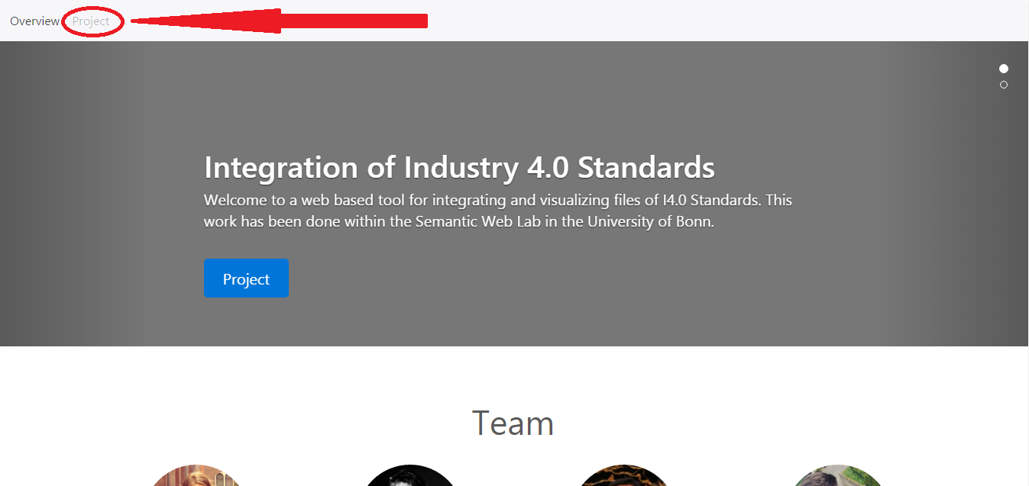

Image 1. Main page.

After that, the form for uploading will appear:

You can select two files of .aml/.opcua type, one by one (Image 2).

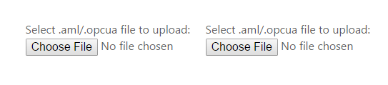

Image 2. Upload form.

# How to produce visualization?

In order to visualize the file, please click on the visualization button and feel free to interact with the graph (Image 3, Image 4).

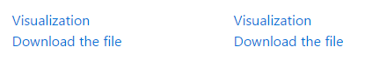

Image 3. Form for visualizing and downloading the file.

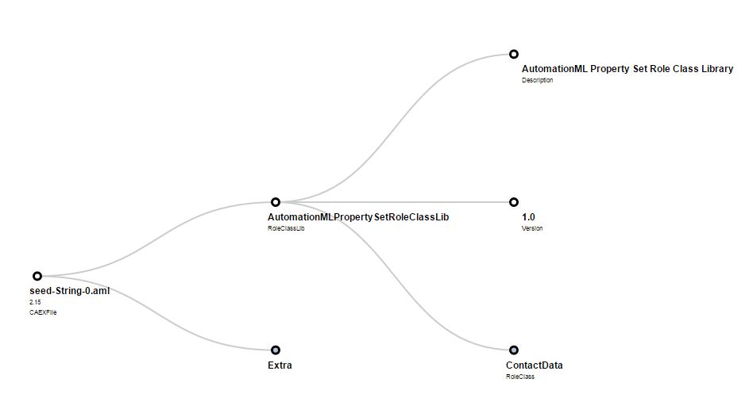

Image 4. Visualized data.

# How to produce an integrated file?

You can choose the way of semantic fuzzy matching of the files and submit files to the server (Image 5).

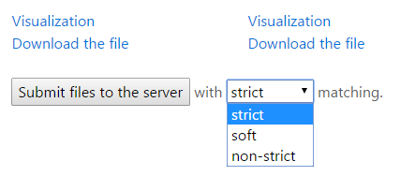

Image 5. Matching selection and submit.

# How to interact with the produced data?

For downloading the integrated file you can choose one out of 4 possible file types (Image 6).

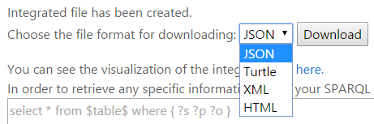

Image 6. Integrated file downloading.

Again, you can interact with the visualization, clicking on the link (Image 4, Image 7). In addition, it is possible to retrieve any data from the produced integrated file using SPARQL (Image 7).

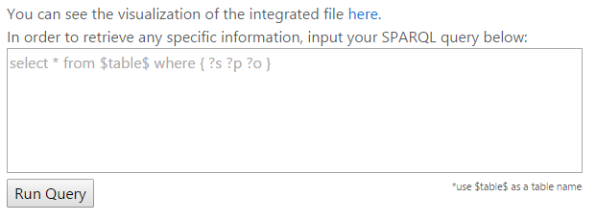

Image 7. Visualization and data retrieving.

Run the query and visualize the result or download it in the JSON format (Image 4, Image 8).

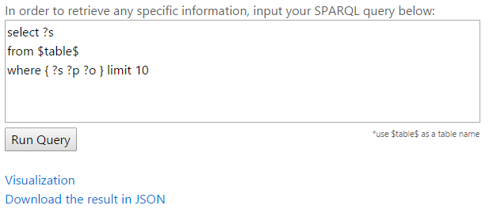

Image 8. Results of retrieving.

# How to communicate with developers?

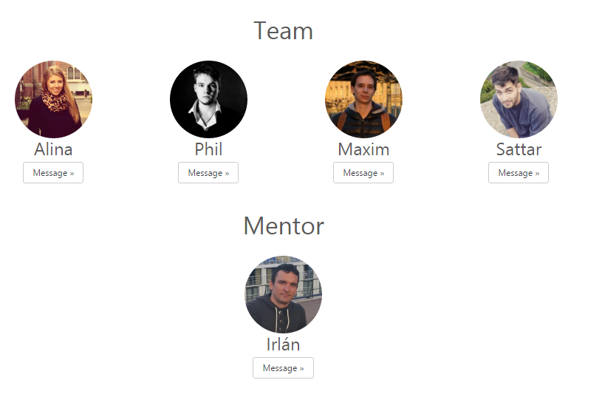

In case of finding any bugs, mistakes in the projects or inability of working with the functionality, our group kindly asks you to contact one of the group members:

Alina Arunova – [alinkamalinkakalinka@yandex.ru](mailto:alinkamalinkakalinka@yandex.ru)

Philipp Matyash- [matyash.phil@gmail.com](mailto:matyash.phil@gmail.com)

Maxim Maltsev – [maltsevmn@ya.ru](mailto:maltsevmn@ya.ru)

Sattar Rahimbeyli - [sattari4@hotmail.com](mailto:sattari4@hotmail.com)